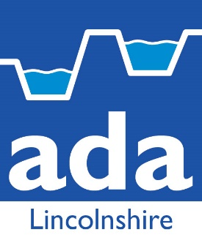

Grant in Aid Applications Manager

We are looking for an experienced, highly motivated, confident and enthusiastic person to join The Lincolnshire Internal Drainage Board team that engages with the Environment Agency (EA) and other Risk Management Authorities (RMA) in relation to applications for Flood and Coastal Erosion Risk Management (FCERM) Grant in Aid, Local Levy etc.

The successful candidate will therefore need the ability to develop strong relationships and have excellent communication and customer service skills to secure customer engagement where you can add the most value to IDB project proposals and applications.

You will be required to work with local colleagues around the County to develop numerous applications throughout the year.

You will need to meet strict deadlines and targets under challenging work pressures.

Essential Experience/Skills

You are likely to be an experienced professional administrator already working with the FCERM Grant in aid sector.

Have excellent organisational skills.

You will be qualified to at least degree standard (or equivalent) in a relevant discipline.

Expected experience and skills include:

- The ability to prioritise incoming tasks from multiple sources and work well to tight deadlines
- The ability to produce all aspects of a detailed economic appraisal through to a business case and funding calculation for FCERM Grant in Aid, working with IDB & EA colleagues
- Exceptional relationship-building, inter-personal and customer skills
- A positive and enthusiastic attitude, with a drive to seek new innovative ways of working
- Strong customer service, communication and relationship building skills – both written and verbal
- Excellent time management and organisational skills and the ability to positively respond to changing and challenging priorities within set timescales
- Self-motivated and able to work both independently and as part of a team
- Ability to make sound decisions based on competing or complex factors
- Strong analytical and decision-making skills
- The ability to work autonomously, judging when to delegate and escalate

Preferred Experience/Skills

Preferred experience and skills include:

- The ability to make connections and share insights/best practice to help join-up work and increase impact
- Establishing and maintaining a wide network which benefits the business through confident negotiation and influencing
- Ability to think strategically and consider the bigger picture

Terms & Conditions

You will be employed and work within the guidelines of the Association of Drainage Association (ADA), Lincolnshire Branch, Wages and Salaries and Conditions of Service 2018 with a starting salary between £34,644 - £37,140 (dependent on experience and skills).

The position offers an essential users car allowance of £2147 per annum with a business mileage allowance.

Applications

If you have the essential experience and skills and an interest in applying for this new interesting and self-motivated position, please do so in writing with a covering letter along with a current copy of your CV before the end of July 2018 to The Chief Executive, Black Sluice Internal Drainage Board, Station Road, Swineshead, Boston, Lincs PE20 3PW.

